

Drotos Engineeering Cloud Migration Project

An Overview



Shane Ẽire Byrne

NTC-300

**Centralized**

Logically as Drotos’s system is a centralized system, this having a server that directs the companies network traffic. The current network layout is a private non-cloud-based IT network. There is no redundancy, a limited Network Attached Storage (NAS), this system is protected by dual firewalls, and does not have any remote access or backup.

With the appropriate upgrades the organization’s network can be converted to a more modern cloud based system which will be more secure, more cost efficient, there is more potential for faster revenue growth, and many other benefits.

Benefits of a cloud-based system1:

1. Cost savings: While there is an initial start up cost to convert the system over to a cloud-based system. Cloud based systems allow easier access to the company’s database(s). they are easily customizable to company needs, they can be in-house ran or subscription based.
2. Security capabilities of cloud systems allow for company information to be kept securely off site if need be. The use of an encryption system on the company’s databases will make it extremely difficult for any data breaches to occur.
3. Cloud based systems allow for flexibility. Company assets can be reassigned where needed within a cloud-system to accommodate the organizations need at any given point in time as it is needed and being used.
4. Cloud based computing allows for greater mobility. Smartphones, tablets, and laptops can easily connect to the organizations cloud allowing for more portable business solutions. Cloud based computing allows for remote access for employees which in turn can be useful for those out in the field.
5. Cloud-based systems can be fitted with analytics to monitor the organizations data. Tracking mechanisms and customized reporting can be established to track the organizations metrics.
6. Cloud systems allow for better disaster control through its redundancy, ergo in the event of system failure the organizations assets are better protected.
7. Most cloud systems are somewhat self-managed. Automatic software updates can be established this in turn saves the company money as less personnel and time are generally required to maintain the system overall. PCWorld itself listed that 50% of cloud adopters cited requiring fewer internal IT resources as a cloud benefit.

**Upgrades**

Depending on the overall health and functionality of the organization’s server it may or may need to be replaced. The addition of solid-state memory as well as redundant storage will help to boost access to the company’s data faster for the users. Redundant storage will also protect the organization’s data. The addition of Hard drive disks (HDD’s) will help to store the organization’s data that may not be used as frequently but is still essential to the organization’s operation. The addition of new hardware can help with the support of the networks needs overall.

Cloud computing contains a repository of IT resources2. This proposal is to convert Droto’s system into a hybrid-cloud system. This will improve the centralized computer system this organization has relied on while adding on the benefits of cloud-based computing.

Why a hybrid-cloud3 one asks?

1. It enables a highly cost effective, rapidly responsive and elastic it this can be better aligned with the business needs.
2. Adaptation to a hybrid cloud allows for a portfolio of an organization and IT that leverage the best capabilities of cloud service.
3. A hybrid-cloud enables an organization to innovate faster while leveraging existing systems and capabilities.

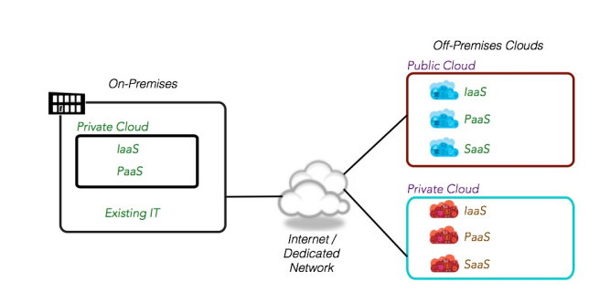

**Scheduling and Balancing3**

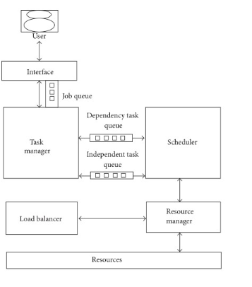

The functions of a cloud can be mitigated through autonomous means. The automation is controlled by a queue system that assigned tasks based on their importance. Tasks are sent to a scheduler where they are carried out in the order of the assignment within their queue. The system itself helps to alleviate the overuse of one particular section of the cloud system allowing for the resources of the system to be evenly distributed.

**Document and Data access**

A cloud computing systesm allows for all documents to be in one place4. These can also have restriction attached to them only allowing certain users access to them. Its possible to set up a tagging/notification system which will help to alleviate e-mail workflow between employees as the other parties can be notified if they need to make alterations to a document on the cloud network. The node structure of a cloud system ensure multiple copies of files are kept in the event of possible failure; the addition of a hybrid cloud system allows for local copies of files to be kept as well.

**Maintenance**

Maintenance of any system is evitable. Hardware is only designed to last so long. One of the major issues most companies face is the hidden cost of maintaining their computing infrastructure. Maintenance contracts can lead to sustained contracts with vendors for years on end5, this leading to countless lost revenue for an organization.

**Other Issues**

In order to best utilize cloud features and to streamline the new system it would be prudent to focus on a few things. First off it would be advisable to renew any specialty licenses that are needed for this organization. Microsoft Office and other such applications would be beneficial to switch to newer versions of these as they generally have better support. In regards to the desire for the possibility for remote working, it would be advisable to enable and set up Bitlocker on any mobile computer that is to be used for the organizations functions; this will encrypt the hard drive of the machine making it harder to break into in the event the device is lost or stolen.

**References**

* Sales Force. (2020). 12 Benefits of Cloud Computing. Retrieved from [https://www.salesforce.com/products/platform/best-practices/benefits-of-cloud-computing/#](https://www.salesforce.com/products/platform/best-practices/benefits-of-cloud-computing/)
* RedHat. (2020). What's the difference between cloud and virtualization?. Retrieved from <https://www.redhat.com/en/topics/cloud-computing/cloud-vs-virtualization>
* Cloud Standards Customer Council. (2016). Practical Guide to Hybrid Cloud Computing. Retrieved from <https://www.omg.org/cloud/deliverables/CSCC-Practical-Guide-to-Hybrid-Cloud-Computing.pdf>
* Devi, D. C., Uthariarai, V. R. (2015). Load Balancing in Cloud Computing Environment Using Improved Weighted Round Robin Algorithm for Nonpreemptive Dependent Tasks. Retrieved from <https://www.ncbi.nlm.nih.gov/pmc/articles/PMC4756214/>
* Macomber, J. (2017). 7 ways cloud software can simplify document management. Retrieved from <https://www.itproportal.com/features/7-ways-cloud-software-can-simplify-document-management/>
* Misra, A. (2013). Software Maintenance - Another Reason to Move to the Cloud. Retrieved from <https://www.netsuiteblogs.com/software-maintenance-another-reason-to-move-to-the-cloud>